Vocabulary

1 Write the correct adjective under each picture.
generous  funny  hard-working  shy  friendly  adventurous
1
2
3
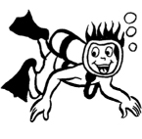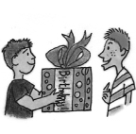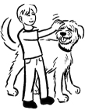
…………………… …………………… ……………………
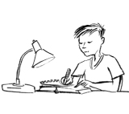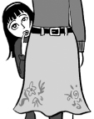
5
4
6
…………………… …………………… ……………………

2 Choose the correct answer.
1. Actors are usually confident / honest / strong people.
2. Sandy plays tennis and football. She’s athletic / lazy / brave.
3. That’s a beautiful picture. You’re very shy / nice / creative.
4. Mark is a doctor. He’s easy-going / clever / weak.
5. Why are you in bed? It’s 11.00 in the morning! You’re friendly / lazy / generous.

3 Use adjectives of personality to write sentences about the members of your family.
1. My mum is .
She isn’t .
2.

3.

Grammar

4 Complete the questions. Then answer them.
1. What …………………… your name?
……………………………………………………………………
2. …………………… you from Madrid?
……………………………………………………………………
3. Where …………………… you now?
……………………………………………………………………
4. …………………… you …………………… a sister?
……………………………………………………………………
5. …………………… your mother adventurous?
……………………………………………………………………
6. When …………………… your class …………………… English lessons?
……………………………………………………………………

5 Write questions with the words below and the correct form of to be or have got.
Then answer the questions about the picture.
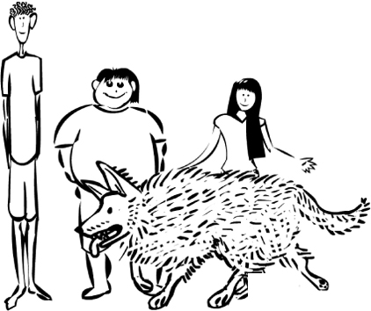
1. Bill / short
Bill
Tim
Kate
Mutt

2. Bill and Kate / small eyes

3. Mutt / fat

4. Mutt / small ears

5. Tim and Kate / curly hair

6. Kate and Tim / tall

